Annexure-6

**Technical procedure for Cancer Cervix Screening**

**by**

**Visual inspection with Acetic acid (VIA) method**

*(Reference: Adapted from Government of India (GoI) guidelines for cancer cervix screening, 2014-15; Monitoring national cervical cancer prevention and control programmes: Quality control and quality assurance for visual inspection with acetic acid (VIA)-based programmes. WHO, Pan American Health Organization (PAHO) and Sankaranarayanan R, Wesley R. A practical manual on visual screening for cervical neoplasia. IARC Technical Publication, No. 41. Lyon, France7 IARC Press; 2003.)*

**Symptoms of Cancer Cervix**

In early stages of cancer cervix, there will be no symptoms. By the time symptoms appear, disease may have already spread. Common symptoms are –

* Post-menopausal bleeding
* Postcoital bleeding
* Intermenstrual bleeding
* Blood stained vaginal discharge
* Excessive seropurulent discharge
* Backache
* Lower abdominal pain

Screening for cancer cervix is recommended for all women aged 30 -59 years. The success of screening is determined by the coverage of women in the target age group rather than the frequency of screening. Once in a lifetime screening for all women between 30 – 59 years will achieve good results at a relatively low cost.

**Visual Inspection tests will be carried out at identified facilities for screening for cancer cervix.**

**Indications of VIA:**

1. Woman between 30-59 years of age with an intact uterus

2. Facility of HPV DNA test is not available

3. Client willing to undergo the test

**Contraindications of VIA:**

1. No specific contraindications are there for the test
2. Though pregnancy is not a contraindication to the test, any unwanted event during the pregnancy may be linked to the test due to ignorance and it is up to the discretion of HCP to perform VIA. If invasive cancer can be excluded/ not suspected on clinical examination, treatment may be deferred after delivery.

In VIA test, a cotton swab soaked in 3-5% acetic acid is applied firmly on the cervix. The results one minute after application of acetic acid should be reported. A VIA test is positive if there is a raised and thickened white plaques or a distinct Aceto-white lesion touching the squamo-columnar junction epithelium. The test is suspicious for cancer if a cauliflower-like fungating mass or ulcer is noted on the cervix. Visual screening result is negative if the cervical lining is smooth, uniform, pink after application of acetic acid and featureless.

Note: Visual screening methods are not recommended for use in postmenopausal women, because their transformation zone usually recedes inside the endocervical canal and squamo-columnar junction is not visible on speculum examination. VIA screening is recommended for women in the age group between 30 and 49 by the WHO. **However, screening of women aged 30 to 59 is planned in this screening program so that women between 50 and 59 age group who have never had a speculum examination at least get a speculum examination by a trained provider.** VIA is likely to havelower sensitivity in this age group and women above 50 will be informed about an HPV test and its advantage over VIA.

**Preparation of 5% acetic acid**

A plastic measuring cylinder can be used for measuring distilled water and a syringe is used for withdrawing 5 ml of glacial acetic acid. Add 5 ml of glacial acetic acid into 95 ml of distilled water. It should be freshly prepared every day and discarded at the end of the day.

|  |  |
| --- | --- |
| C:\Users\Smita Joshi\Desktop\c0739a4b-75f7-465d-9f26-ac7df6745052177.jpg | C:\Users\Smita Joshi\Desktop\5syringe.jpg  5 ml syringe for glacial acetic acid |
| Plastic measuring cylinder for distilled water | Take 95 ml of distilled water and add 5 ml of glacial acetic acid to make 5% acetic acid. |

**Materials and equipment needed**

* Soap and water for washing hands / hand sanitizer
* A bright halogen light source / halogen torch to examine the cervix
* Wall clock to note time of application of acetic acid
* A bivalved speculum, high-level disinfected (it need not be sterile)
* Examination table covered by clean paper or cloth / mackintosh
* Autoclaved cotton-tipped swabs / autoclaved drum of cotton balls of appropriate size and sponge holding forceps
* Dilute acetic acid solution (3-5%)
* 0.5% chlorine solution for decontaminating instruments and gloves
* 0.5% chlorine solution spray for cleaning the mackintosh after examining every client
* Consent form
* Case report form
* Client report card

**Preparation**

1. Explain the procedure, how it is done and what a positive test means.
2. Ensure that the woman has understood the counseling and obtain an informed consent.

**Procedure**

* Insert a bivalved speculum
* Adjust the light source to get the view of the cervix.
* If required, use a saline moistened cotton swab to remove any discharge, blood or mucus from the cervix.
* Identify the Squamo-Columnar Junction (SCJ), and the area around it.
* Apply acetic acid to the cervix; continue to apply intermittently for one minute and simultaneously observe if any color change develops.
* Observe any changes in the appearance of the cervix. Give special attention to abnormalities close to the transformation zone.
* Inspect the SCJ & transformation zone carefully and be sure you can see all of it. Report if the cervix bleeds easily. Look for any raised and thickened white plaques or acetowhite epithelium. Remove any blood or debris appearing during the inspection.
* Use a fresh swab to remove any remaining acetic acid solution from the cervix and vagina.
* Gently remove the speculum.

**After screening**

* Record your observations and the test result. Draw SCJ & a map of any abnormal findings on the record form.
* Discuss the results of the screening test with the patient. If the test is negative, tell her that she should have another in 3-5 years. If the test is positive or cancer is suspected, tell her what the next recommended steps are. If she needs further testing or treatment, make arrangements and provide her with all necessary forms and instructions before she leaves. If you can make the appointment immediately, do so.

**Criteria for categorizing VIA test results**

***VIA negative (-)***

VIA screening is reported as negative in the case of any of the following observations:

* No acetowhite lesions are observed on the cervix
* Polyps protrude from the cervix with bluish-white acetowhite areas
* Nabothian cysts appear as button-like areas, as whitish acne or pimples
* Dot-like areas are present in the endocervix, which are due to grapelike columnar epithelium staining with acetic acid
* There are shiny, pinkish-white, cloudy white, bluish-white, faint patchy or doubtful lesions with ill-defined, indefinite margins, blending with the rest of the cervix
* Angular, irregular, digitating acetowhite lesions, resembling geographical regions, distant (detached) from the squamocolumnar junction (satellite lesions)
* Faint line-like or ill-defined Aceto-whitening is seen at the squamocolumnar junction
* Streak-like Aceto-whitening is visible in the columnar epithelium
* There are ill-defined, patchy, pale, discontinuous, scattered acetowhite areas

***VIA positive (+)***

The VIA test outcome is reported as positive in any of the following situations:

• There are distinct, well-defined, dense (opaque, dull- or oyster-white) acetowhite areas with regular or irregular margins close to or abutting the squamocolumnar junction in the transformation zone or close to the external os if the squamo-columnar junction is not visible

• Strikingly dense acetowhite areas are seen in the columnar epithelium

• The entire cervix becomes densely white after the application of acetic acid

• Condyloma and leukoplakia occur close to the squamo-columnar junction, turning intensely white after application of acetic acid.

***VIA positive, invasive cancer***

The test outcome is scored as invasive cancer when:

• There is a clinically visible ulcero proliferative growth on the cervix that turns densely white after application of acetic acid and bleeds on touch.

**Also given below is a flowchart/expert panel recommendation from WHO for making appropriate decisions regarding the next course of action –**

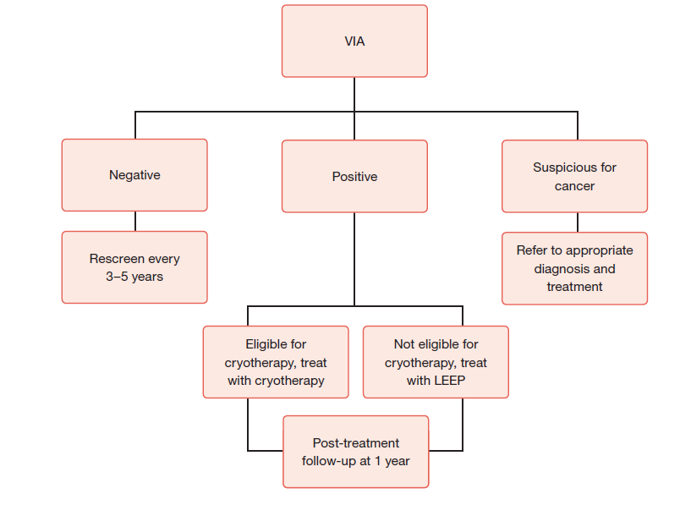

(Source: WHO guidelines for screening and treatment of precancerous lesions for cervical cancer prevention, 2013)

**Treatment of VIA Positive cases by Cryotherapy procedure**

*(Reference: Adapted from Monitoring national cervical cancer prevention and control programmes: Quality control and quality assurance for visual inspection with acetic acid (VIA)-based programmes. WHO, Pan American Health Organization (PAHO))*

Cryotherapy is freezing of the abnormal areas on the cervix by the application of a very cold disc.

**Cryotherapy equipment components (Wallach System)**

1. ***Probe***

***2. Trigger***

***3. Handle grip (fibreglass)***

***4. Yoke***

***5. Inlet of gas from cylinder***

***6. Tightening knob***

***7. Pressure gauge showing cylinder pressure***

***8. Silencer (outlet)***

***9. Gas-conveying tube***

***10. Probe tip***



***10***

***8***

***7***

***1***

***3***

***2***

***9***

***6 4 5***

Source: Comprehensive Cervical Cancer Control: A Guide to Essential Practice

**Indications of Cryotherapy:**

1. VIA positive*

* Treat with cryotherapy if the entire lesion is on the ectocervix, squamo-columnar Junction is fully visible & when lesion does not cover more than three quarters of ecto-cervix and does not enter the endo-cervical canal or does not extend to the vagina

**Contraindications of Cryotherapy:**

1. Lesion extends 2 mm beyond the cryoprobe being used.

2. Lesion extends into the endo-cervical canal

3. Lesion covers more than three quarters of cervix.

4. Lesion suspicious of invasive carcinoma

**Materials and equipment needed for cryotherapy**

* A high-level disinfected speculum
* Disposable or high-level disinfected examination gloves
* Cotton swabs for wiping the cervix (autoclaved in a drum)
* Normal saline solution
* Cryotherapy unit with adequate gas supply
* Colposcope (in case if it is available at Rural Hospital)

**Before the procedure**

1. Explain the procedure and why it is important to return for further management as requested. Ensure that the woman has understood the procedure and obtain informed consent.
2. Show her the cryotherapy equipment and explain how you will use it to freeze the abnormal areas on the cervix.
3. Prepare the patient for a gynecological examination and perform a speculum examination. Use a large size bivalved speculum. If the vaginal walls are obstructing the view, you can use a condom cut at both ends and insert the speculum into the condom and then insert the speculum (with the condom) in the vagina.
4. If there is a cervical infection, provide treatment and prescribe some antibiotic (preferably Tab Doxycycline 1BID for 7 days and Tab Metronidazole 1 BID for 7 days). If there is discharge, you may still proceed with the cryotherapy, or you may give the patient an appointment to return once the infection is cured.

**Procedure**

1. If required, wipe the cervix with a saline-soaked cotton swab, Apply acetic acid to outline the abnormality. Tell the woman she might feel some discomfort or cramping while you are freezing the cervix.
2. **Wipe the cryoprobe surface with saline to ensure optimum effectiveness.**
3. Apply the cryoprobe tip in the centre of the os and make sure the probe adequately covers the lesion (Figure 1). If the lesion extends more than 2 mm beyond the probe, discontinue the procedure. Ensure that the vaginal wall is not in contact with the cryoprobe or you may cause a freezing injury to the vagina.

**Figure 1: Position of Cryoprobe on the cervix and ice formation**

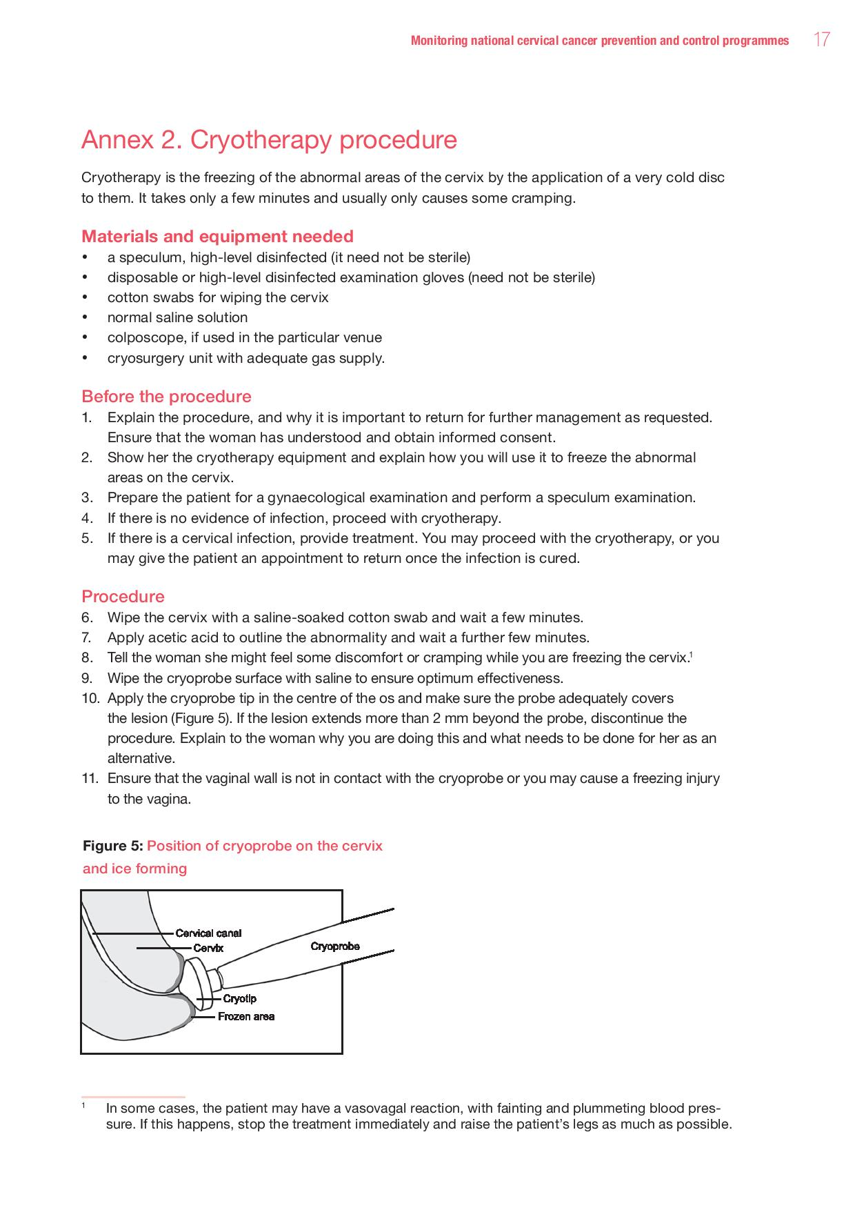

1. Set the timer and release the gas trigger to cool the probe.
2. You will observe the ice forming on the tip of the cryoprobe and on the cervix (Fig. 1). When the frozen area extends 4-5 mm beyond the edge of the cryoprobe, freezing is adequate.
3. Allow two cycles of freezing and thawing: 3 minutes freezing, followed by 5 minutes thawing, followed by a further 3 minutes freezing and 5 minutes of thawing.
4. Once the second freezing is complete, allow time for thawing before attempting to remove the probe from the cervix. Removing it before it is fully thawed will pull tissue off the cervix.
5. Gently rotate the probe on the cervix to remove it. The area you have frozen will appear white.
6. Examine the cervix for bleeding. If bleeding is noted, apply Monsel’s paste.
7. Do not pack the vagina.
8. Remove the speculum.

In some cases, the patient may have vasovagal reaction, with fainting and fall in blood pressure. If this happens, stop the treatment immediately and raise the patient’s legs as much as possible. Treatment may be completed after recovery after assuring the patient or give an appointment of a later date.

**After the procedure**

|  |
| --- |
| 1. Provide a sanitary pad. 2. Instruct the woman to abstain from intercourse and not to use vaginal tampons for 4 weeks to avoid any infection. 3. Inform the woman that she may have mild cramping pain in abdomen for a few days and discharge for about 4-6 weeks 4. Provide condoms for use if she cannot abstain from intercourse as instructed. Teach her how to use them. 5. Invite the patient to return after 6 weeks to be checked for healing and again in 12 months for a repeat VIA test and possibly colposcopy. 6. Inform her of possible complications and ask her to return immediately if she notes:    * + fever with temperature higher than 38°C or shaking chills      + severe lower abdominal pain      + foul-smelling or pus-like discharge      + Bleeding for more than two days or bleeding with clots. 7. Routine use of antibiotics is not recommended after treatment with cryotherapy. Provide antibiotics (preferably Doxycycline and Metronidazole for 7 days) only if there is discharge prior to treatment with cryotherapy. 8. Clean and disinfect the cryoprobe and decontaminate the cryogun, tubing, pressure gauge and gas tank. 9. Decontaminate the cryotherapy unit, hose and regulator by wiping them with alcohol. 10. Wash the cryotip and the plastic sleeve with soap and water until visibly clean. 11. Rinse the cryotip and plastic sleeve thoroughly with clean water. 12. High-level disinfect the cryotip and plastic sleeve by one of the following methods:     * 1. boil in water for 20 minutes; or       2. steam for 20 minutes; or       3. Soak in chemical disinfectant (0.1% chlorine solution or 2% Glutaraldehyde) for 20 minutes and then rinse with boiled water. 13. It is critical that the hollow part of the cryotip is completely dry when next used, otherwise the water will freeze and the probe could crack or the treatment will not work. 14. Either use a rubber cap to seal off the hollow part of the cryoprobe during processing, or thoroughly dry the cryoprobe before it is reused. |

**Follow-up after cryotherapy**

1. Perform a P/S examination to check for healing about 6 weeks after cryotherapy.
2. At 12 months, do a VIA test again. If VIA is positive, do colposcopy and take a biopsy if necessary or refer as required. If available, an HPV test or cytology may also be advised.

-----------------------------------x------------------------------------